Chapter 6 – Network Configuration & Remote Administration

Objective
Configure Ubuntu Server networking for the Wazuh Home Lab by:
- Configuring a static IP address.
- Using two network adapters.
- Managing the server remotely using SSH.

Why Does Wazuh Need a Static IP?
A Static IP Address is a permanent IP address that does not change after reboot. Example:
192.168.56.10

Why is it important?
  - Wazuh Agents communicate with the Wazuh Manager using its IP address.
  - If the Manager's IP changes, agents lose communication.
  - Servers should always use static IP addresses.

DHCP vs Static IP
DHCP (Dynamic Host Configuration Protocol)
  - Automatically assigns IP addresses.
  - IP addresses may change after reboot. Example:
Today 192.168.56.102

Tomorrow 192.168.56.105

Advantages
  - Automatic configuration
  - Easy to manage

Disadvantages
  - IP address is not permanent.

Static IP
  - Configured manually.
  - Remains the same until changed. Example:
192.168.56.10

Advantages
  - Stable
  - Predictable
  - Recommended for servers

Why Two Network Adapters?
Our Ubuntu Server uses two interfaces.

Adapter 1 – NAT
Purpose:
  - Internet Access
  - Ubuntu Updates

  - Download Wazuh Packages Interface
enp0s3 Example IP 10.0.2.15

Adapter 2 – Host-Only
Purpose:
  - Private communication between VMs
  - Wazuh Agent communication
  - Kali attack simulation Interface
enp0s8 Static IP
192.168.56.10

Lab Network Design
Internet
│ VirtualBox NAT
│
Ubuntu Server (enp0s3)
10.0.2.15 (DHCP)

──────────────────────────────────

Host-Only Network

Ubuntu Server 192.168.56.10

↓

Windows

↓

Kali Linux

Netplan
Netplan is Ubuntu's network configuration utility. Used to configure:
  - Static IP
  - DHCP
  - Gateway
  - DNS
  - Network Interfaces Configuration files are stored in:

/etc/netplan/ Example:
/etc/netplan/00-installer-config.yaml

YAML
YAML stands for:

YAML Ain't Markup Language
It is a human-readable configuration format used by tools such as:
  - Netplan
  - Docker Compose
  - Kubernetes
  - Ansible

Important Rule
YAML depends on spaces, not tabs.
Incorrect indentation causes configuration errors.

Backup the Configuration
Always create a backup before editing system configuration files.

Command
sudo cp /etc/netplan/00-installer-config.yaml \
/etc/netplan/00-installer-config.yaml.backup Purpose:
Restore the original configuration if needed.

Edit Netplan Command
sudo nano /etc/netplan/00-installer-config.yaml Purpose:
Edit the network configuration.

Static IP Configuration
Example: network: version: 2

ethernets: enp0s3:
dhcp4: true dhcp6: true

enp0s8:
dhcp4: false addresses:
- 192.168.56.10/24

Explanation

Setting | Purpose
network: | Starts the network configuration
version: 2 | Netplan configuration version

ethernets: | Defines Ethernet interfaces
enp0s3 | NAT interface
dhcp4: true | Automatically obtain IPv4 address
enp0s8 | Host-Only interface
dhcp4: false | Disable DHCP
addresses: | Assign static IP
/24 | Subnet mask (255.255.255.0)

Validate Configuration Command
sudo netplan generate Purpose:
Checks the YAML syntax before applying changes. If there is no output, the configuration is valid.

Test Configuration Command
sudo netplan try Purpose:
  - Temporarily applies the configuration.
  - Automatically rolls back if there is a problem.

Apply Configuration Command

sudo netplan apply Purpose:
Applies the network configuration permanently.

Difference Between netplan try and netplan apply netplan try netplan apply
Tests configuration Applies configuration permanently Automatically rolls back on failure No automatic rollback Recommended before applying Used after successful testing

Verify Network Display IP Addresses ip addr

Display Routing Table
ip route

Check Internet
ping google.com

Display Hostname
hostnamectl

Remote Administration Using SSH

What is SSH?
SSH (Secure Shell) is a secure protocol used to remotely manage Linux servers over an encrypted connection.
Instead of working directly in the VirtualBox console, administrators connect to the server from another computer.

Why Use SSH?
  - Secure encrypted communication
  - Remote administration
  - Easy copy and paste
  - Faster than using the VM console
  - Standard method used by Linux administrators and SOC analysts

Verify SSH Service sudo systemctl status ssh If SSH is not running: sudo systemctl enable ssh sudo systemctl start ssh

Connect from Windows
Open:
  - Windows PowerShell
  - Windows Terminal Command:
ssh username@ip-address

Example:
ssh kashifkhan@192.168.56.10
After connecting, enter your Ubuntu password.
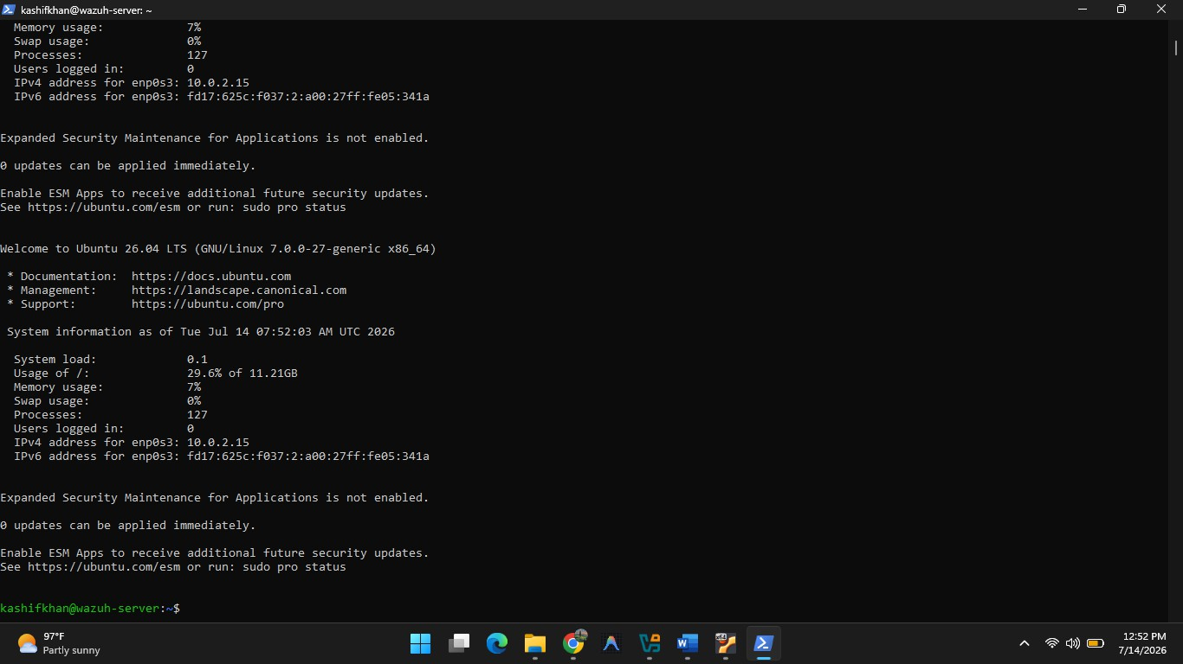

Common Windows SSH Issue Problem
ssh : The term 'ssh' is not recognized...

Cause
The OpenSSH Client is installed but the OpenSSH directory is not available in the Windows PATH.
Verify where.exe ssh Temporary Fix
$env:Path += ";C:\Windows\System32\OpenSSH"

Permanent Fix
Add the following directory to the Windows Path environment variable: C:\Windows\System32\OpenSSH

Final Network
Interface Purpose IP Address
enp0s3 NAT 10.0.2.15 (DHCP)
enp0s8 Host-Only 192.168.56.10 (Static)

Chapter 6 Summary
  - Wazuh Manager requires a Static IP Address.
  - Use NAT for Internet access.
  - Use Host-Only for communication with lab machines.
  - Ubuntu uses Netplan to manage networking.
  - Validate configuration using netplan generate.
  - Test using netplan try.
  - Apply using netplan apply.
  - Verify using ip addr, ip route, and ping.
  - Manage Ubuntu remotely using SSH from Windows.

Commands Cheat Sheet

Command | Purpose
ip addr | Display IP addresses

ip route | Display routing table
hostnamectl | Display hostname
sudo nano /etc/netplan/00-installer-config.yaml | Edit Netplan
sudo cp backup | Backup Netplan file
sudo netplan generate | Validate YAML syntax
sudo netplan try | Test configuration
sudo netplan apply | Apply configuration
ping google.com | Verify Internet connectivity
sudo systemctl status ssh | Check SSH service
ssh username@ip-address | Connect remotely using SSH

